# **Rainbow Beach Tourist Centre**

## There's So Much To See And Do In Rainbow Beach.

*Beautiful Rolling Surf, Sandy Unspoiled Beaches And Surrounding National Parks Make Rainbow Beach The Perfect Place To Get Away Form It All. A Former Sand Mining Town, Rainbow Beach Is The Gateway To Fraser Island.*

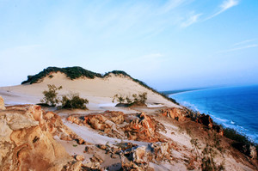

**Carlo Sand Blow**

While Staying At Rainbow Beach, A Visit To The Carlo Sand Blow Is A Must. The Scenery From The Top Is Just Stunning With Views Of Double Island Point, Tin Can Bay And The Coloured Sands. To Get There Drive To The End Of Cooloola Drive And Take A Short Walk Along A Wooded Track To The Natural Sand Blow. You Won't Be Disappointed. Extra Special Times To Visit Are Sunrise Or Sunset ... Spectacular!

# **Buddha and Beach**

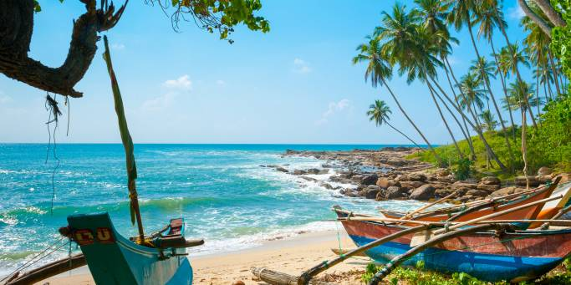

Explore Dambulla Rock Temple and ancient Polonnaruwa and visit iconic Sigiriya Rock. Sip on refreshing Ceylon tea and take a jeep ride into Udawalawe National Park before heading to the idylic beaches of Bentota for some sun, sea, rest and relaxationolonnaruwa was once the capital and is also the second most ancient city in Sri Lanka. It is now a UNESCO World Heritage Site and was once

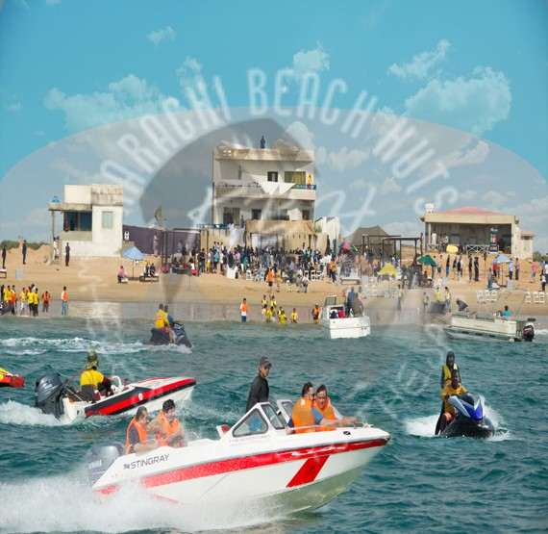**KARACHI HUTS**

Karachi Beach Huts is a unique opportunity to explore and discover, with your friends or family, the hidden treasures of the Beach. We Provide Beach Huts for Picnics, Parties, Birthdays, Anniversaries, Picnics and Family gatherings and all type of beach activities.   
  
We provide huts for rent on perfect spots on Karachi's coastline with clean and safe environment where no outsiders are allowed giving a total privacy protection and excellent services to our clients.   
  
We organize complete corporate events at beach. We’ll make sure you get the most fun out of the hut!

# **SeeWhales Harbor Breeze Cruises**

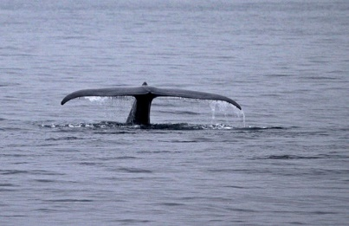

We are the top destination for **whale** watching in Long Beach & Los Angeles. Join **Harbor Breeze Cruises** on an exciting California **whale** watching journey to **view** some of the largest mammals on the planet. ... Please visit www.lawaterfrontcruises.com for more **information**. **Harbor Breeze Cruises** has provided **whale** watching, world port & charter cruises for over 18 years in the Los Angeles & Orange County ... Danny has worked on perfecting his harbor cruise business.**Harbor Breeze Cruises** ticket reservation system. ... **Information** Phone Hours: ... You will learn history about the harbor as well as **see** the beautiful Long ... We will also search for Humpback **Whales**, Fin **Whale**